Information for Volunteers
Volunteers staying onboard (5 days+)

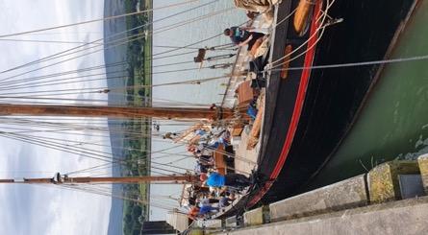
We are Silvery Light Sailing, a registered charity in Northern Ireland and owners of the tall ship LEADER. We run sail training voyages for young people and community groups in and around the UK and Ireland.

LEADER is a 130 year old Brixham Trawler & Class B Tall Ship. She was made in 1892, and is a gaff ketch. She has 17 berths, and when at sea is usually sailed by 3 professional crew and 12 guests/trainees.

We need volunteers to help us with LEADER's winter maintenance. There's lots to do to make sure she's in top condition and looking good for the start of the sailing season in April 2023.

We require help with tasks such as:
- Sanding, scraping, priming and painting  - Joinery and wood repairs  - Marine plumbing and electrics  - Cleaning | - Maintenance of the rigging and lines  - Organising stores/lifejackets/oilies  - Repairing the sails  - ... and much more!
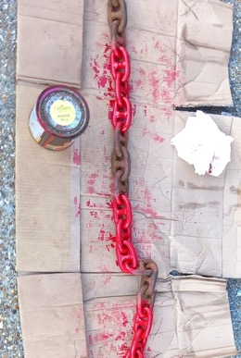
Example of a job we’ve already completed: painting new marks on the anchor chain
There are a few big jobs, like we'll be scraping the entire hull of the boat and repainting it, which will be a team effort - but also smaller tasks that one or two people can work on at a time.

No experience necessary, but enthusiasm is essential!

We can teach you about taking care of a heritage vessel, but this really comes with lots of transferable skills you'll find useful in other areas of life. Improve your DIY skills and become more confident tackling those kinds of jobs yourself.

What’s the accommodation like?
- Single berth (bunk bed) in a communal living space onboard
- Privacy curtains on the bunks and between living spaces
- Large saloon with cushioned bench seating
- Fully equipped galley (kitchen)
- Toilets may be temporarily unavailable onboard due to the work being carried out, but there are toilets & showers in the harbour, & a laundry nearby
- We are connected to electricity on the shore, and have UK style plugs

Get the chance to live onboard a 130 year old tall ship, its not your average hostel or hotel!

Join our crew and other like-minded volunteers to live together, eat together and enjoy the work together. There's a large saloon, taken up mostly by a table big enough for 17 people and cushioned bench seating. This is where meals can be eaten, but if the weather is mild you can always take your food up on deck and enjoy the fresh sea air. It also provides a comfortable space to socialise, play cards, read a book...
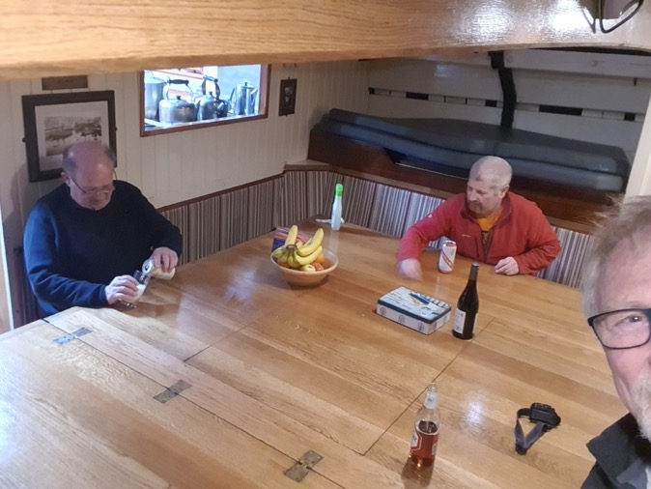  The saloon, massive foldout table for food and games | 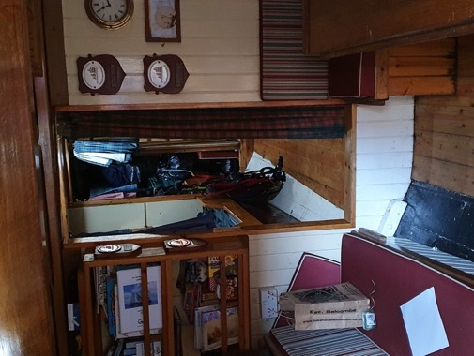  View into the sleeping quarters
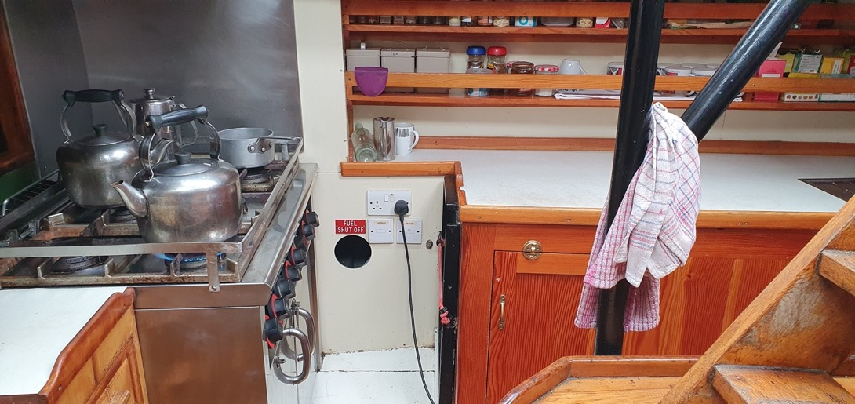
The galley (kitchen), we have a stove, oven, fridge, freezer and plenty of storage

How will food work?
- We provide 3 meals a day on the days you are working, with some provision for your days off too
- Please let us know about any allergies or dietary requirements to see how we can accommodate
- Cooking and cleaning is a job shared by all staying on board, we take turns to prepare food
- You are welcome to bring your own snacks or favourite teas/coffee for your personal use
- We’d be delighted if you would like to share a particular cultural dish with us, talk to the crew!

Example menu items:
Breakfast  Cereals, toast, fruit, yogurt | Lunch  Sandwiches, soup, crisps, salad | Dinner  Spagetti Bolognese, chilli and rice, pizza and garlic bread

The food that is bought and prepared will depend on who is board that week, we have a budget but we’re always open to requests and ideas for the group’s food. Tea and coffee always available!

Closer look at the sleeping quarters
Not all accommodation will be open, as some work will be happening below deck – so we’ll cordon off an area of bunks that is purely for sleeping – and your bunk is your space. As there will be empty bunks, there will be some space for your bags etc. but we always recommend a soft bag like a holdall for easy storage. Please no suitcases!

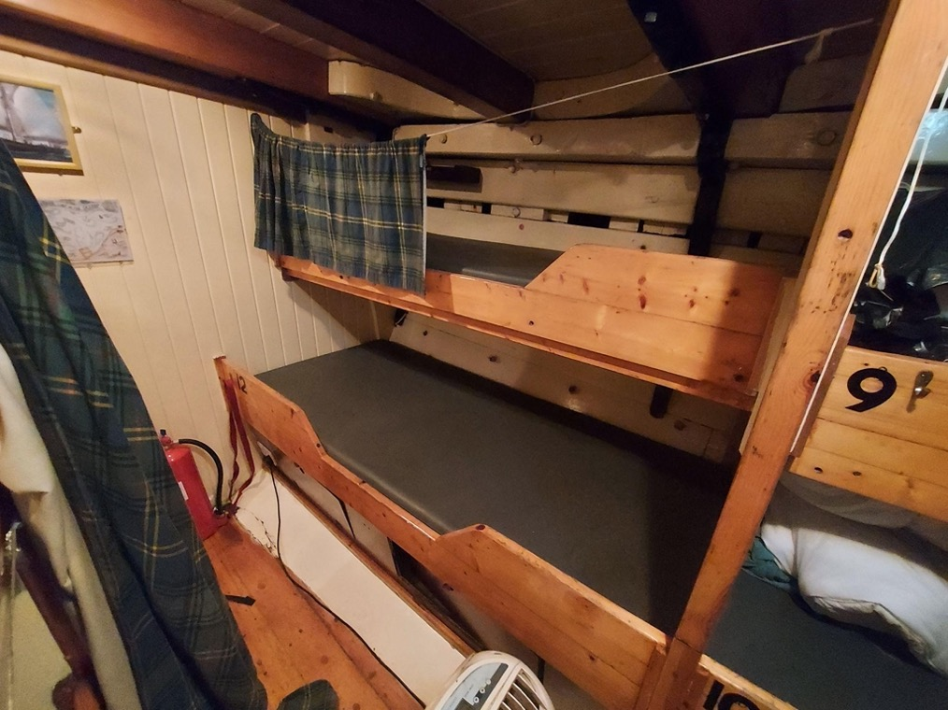

Where is the boat harboured? | Google Maps link | Kilkeel Harbour  Kilkeel  County Down  BT34 4AX
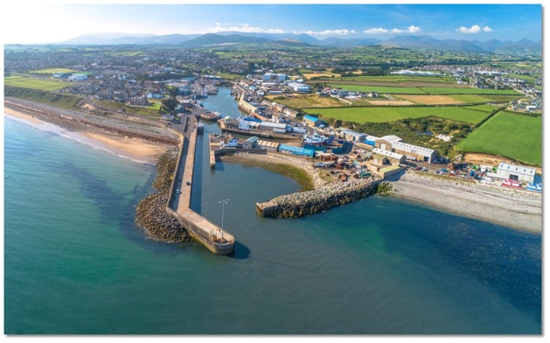
View of Kilkeel Harbour and town
The boat is in Kilkeel, a small port town on the east coast of Northern Ireland, near the Irish border.

Kilkeel is a town of 6000+ people, and within walking distance of the boat you'll find shops, Post Office, bank/ATM, pubs, restaurants/cafes, internet access, doctors, laundry, and a chandlery.

There is public transport, with routes by bus to nearby Newry and Newcastle, but these services don’t operate late into the evening (last bus from Newry departs 1815, last bus from Newcastle, departs 2115).

We can also assist with transfers and lifts if needed, just let us know if we can help!

Travel times to nearby destinations
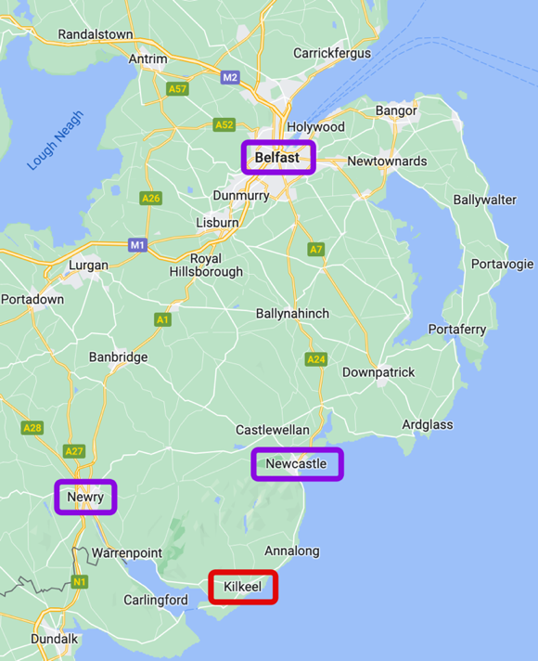 | Newcastle  - 24min by car  - 38min by bus, Service No. 37
Newry
- 30min by car
- 55min by bus, Service No. 39
Belfast
- 1hr 10min by car
- 2hr 7min by bus, Service 37 & 520
- 2hr 56min by bus, Service 39, 45 & 538
Dublin
- 1hr 45min by car
- 3hr 26min by bus, Service 39 & X1
Enterprise Train
Cross-border train service, serving a Dublin to Belfast line, stops in Newry

Airports
Belfast International Airport
Belfast City Airport
Dublin Airport

What can I do in my time off? What is there to see nearby?
While you’re always welcome to spend your down time on the boat, we encourage all of our volunteers to explore the local area, because there’s more to your experience here that just the work on board.

Staying in Kilkeel, there’s a Leisure Centre where you can go to the gym, spa or swimming pool.
You can go to the gym without booking ahead, but you’ll need to book a swimming session.

There’s also a visitor centre that’s open Mon-Fri 9-5pm (closes for lunch), and you can find out about any local events or points of interest on the Visit Kilkeel website

While the whole area is picturesque and full of rural charm - there are also several walking hotspots nearby for those who would like to take a hike. Close by we have:
- Mourne Country Park (2.9 miles)
- Silent Valley Mountain Park (4.8 miles)
- Rostrevor Forest (12.5 miles)
- Tollymore Forest Park (16 miles)
- Slieve Gullion Forest Park (23 miles)
- The Mourne Mountains. The trail to the highest summit, Slieve Donard, begins in Newcastle

Our nearest city is Newry, where you can enjoy cultural attractions like Newry Cathedral or the Newry and Mourne museum. There’s many restaurants, hotels and pubs. Every Thursday and Saturday the council organise a market with around 70 local sellers in attendance. | Just up the coast there is Newcastle, right at the bottom of the Mourne Mountains. A popular holiday spot, with lots of places to eat out and amusement arcades. Take a walk along the seafront with an ice cream or buy some souvenirs at the gift shop.
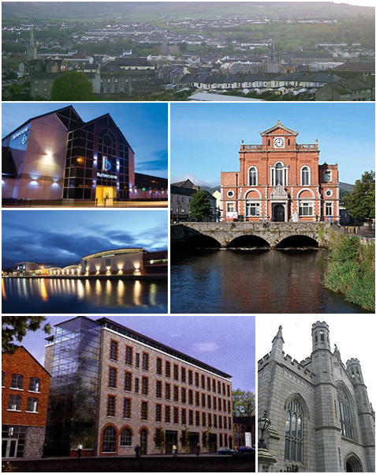 | 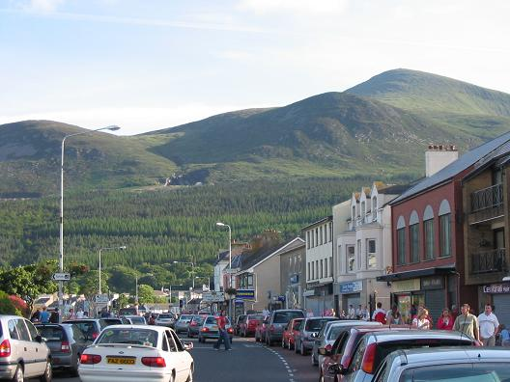  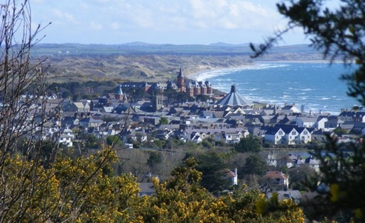

Who will I be volunteering with?
We have 2 professional crew, a Mate and a Bosun + the onshore staff team and charity trustees who are ready to welcome and support you on our project. We value your time, and that you've chosen to spend it helping us, and will do our best to help you get the most out of this experience.

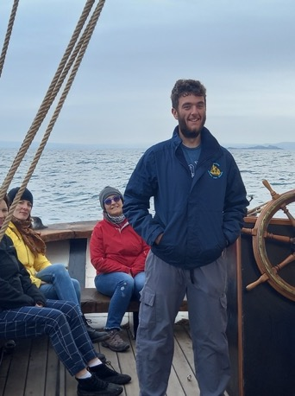 | 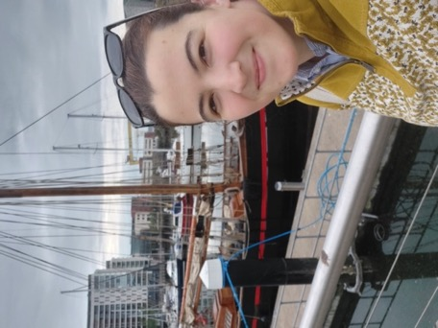 | 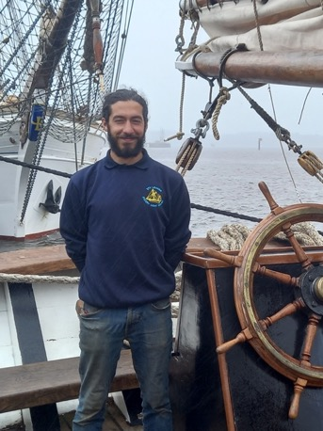
Odhran  Bosun | Belinda  Community Support Worker | Alberto  First Mate

More details about the work involved:
- The average work load will be a maximum of 5hrs per day, 5 days a week
We do ask for some flexibility, for example: some days we’ll need all hands on deck (literally!) for a big job which could take the whole day. In which case, you’d have an extra day off that week.
- The work will be directed by a member of our crew, or the onshore team. We have a list of jobs to get through over the winter, and some will be higher priority than others. We don’t expect you to already know what to do – we will set you up with a task and make the right equipment and guidance available to you.
- Your decision to volunteer your time and effort on the project should be of benefit to you as well as to the boat. Let us know what your skills are, and what areas you’d like to improve in. Want to learn more about knots and splices? Practice whipping lines? Become a better painter?
Whether you are pursuing a career in the traditional seafaring industry or just hear to donate your time and soak up a new experience – this is an opportunity for you to develop your skills too.

Ready to come aboard?
Send your completed application form to office@silverylightsailing.com

Not sure this is for you?
We have other opportunities for folks to get involved outside of maintenance and working onboard.
Read about other ways to support Silvery Light Sailing on the website, or drop us an email at the above.

Silvery Light Sailing, November 2022

